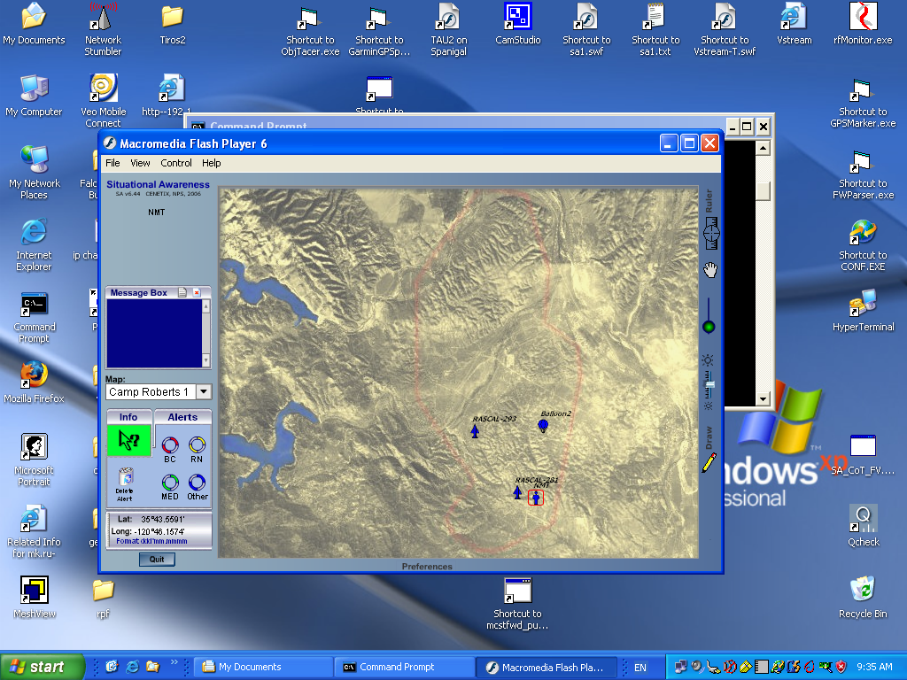
test scrn capture 1
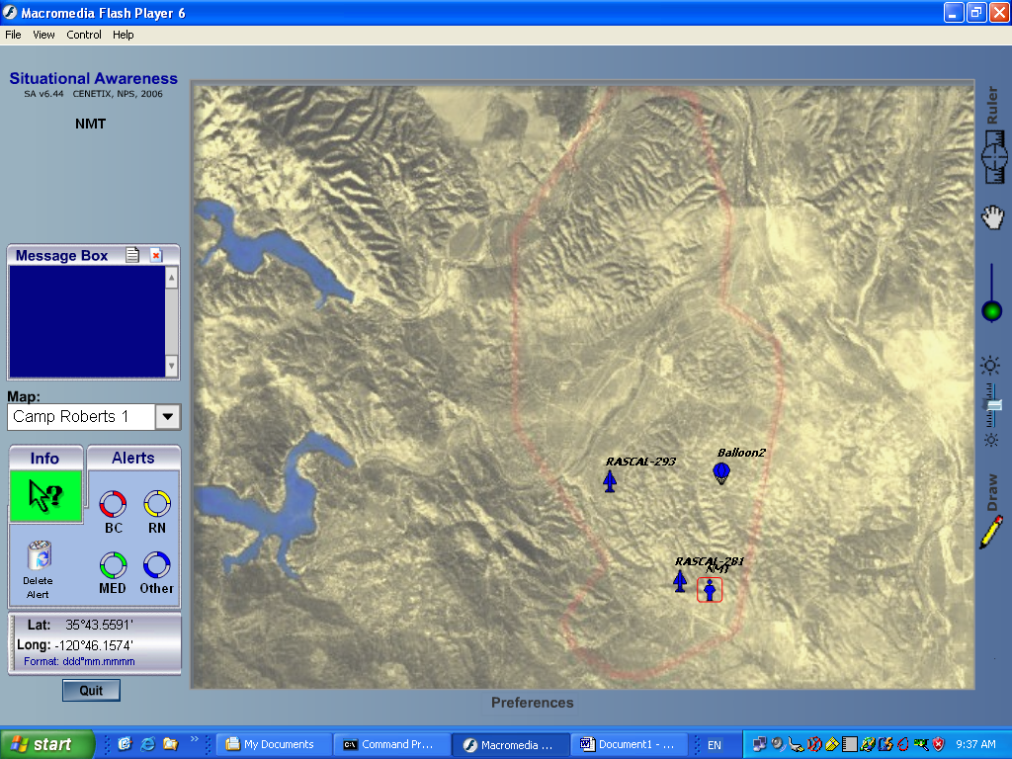
test scrn capture 2
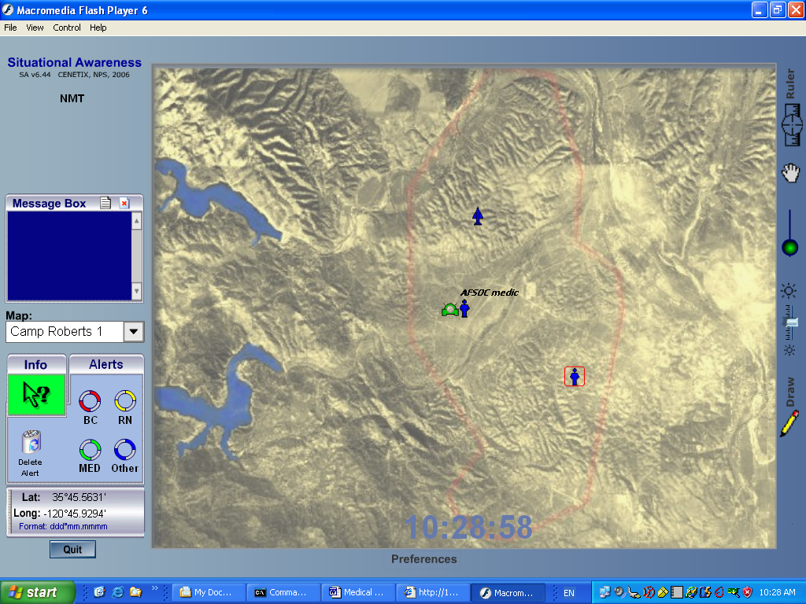

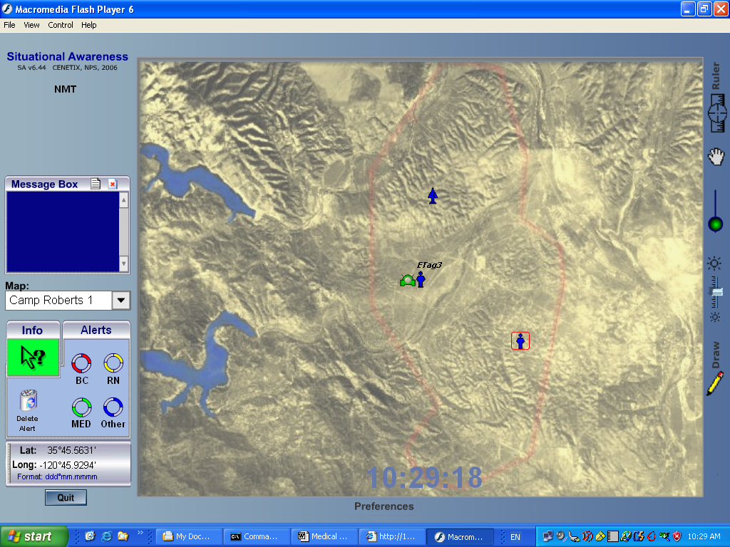
E-Tag 3 first seen in TOC
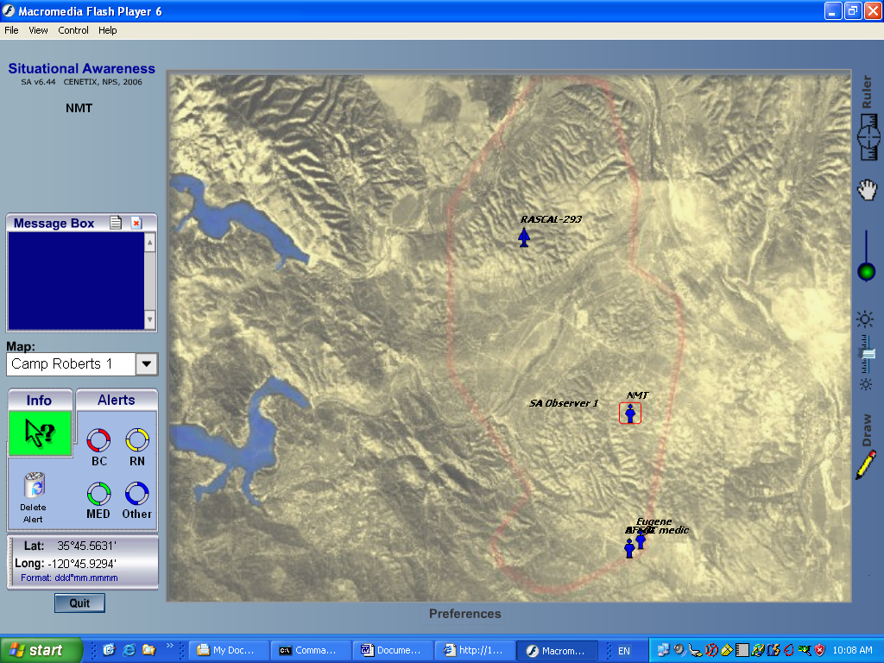
Medic icon first seen in TOC SA

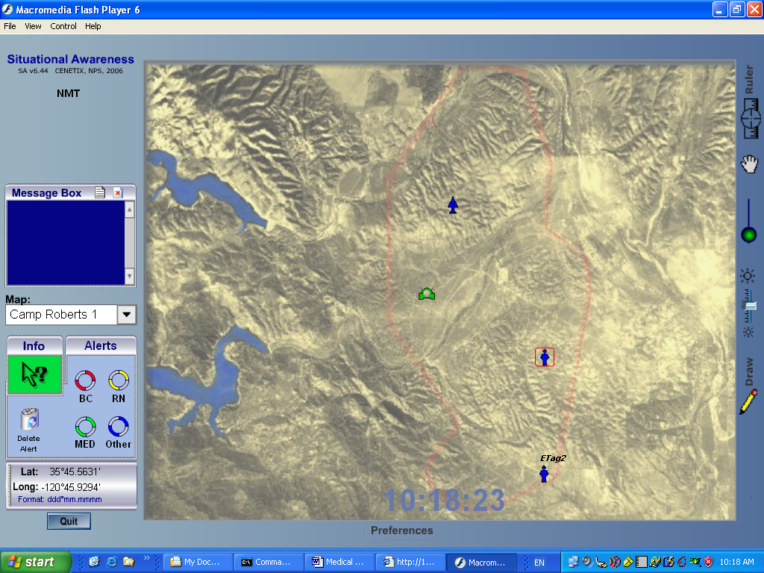

ETAG 2 first seen in TOC SA

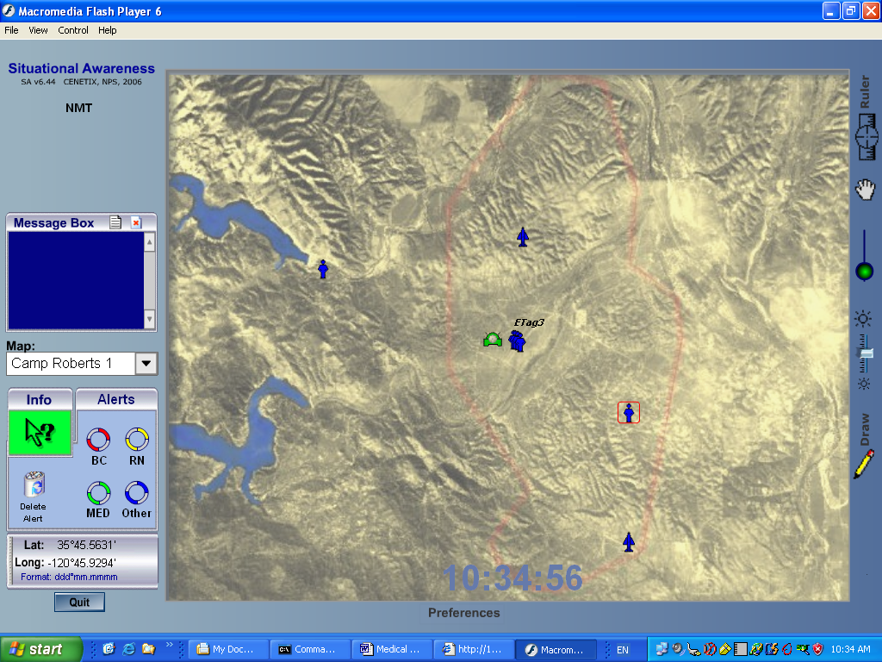

E-TAG 1-4 seen in TOC SA
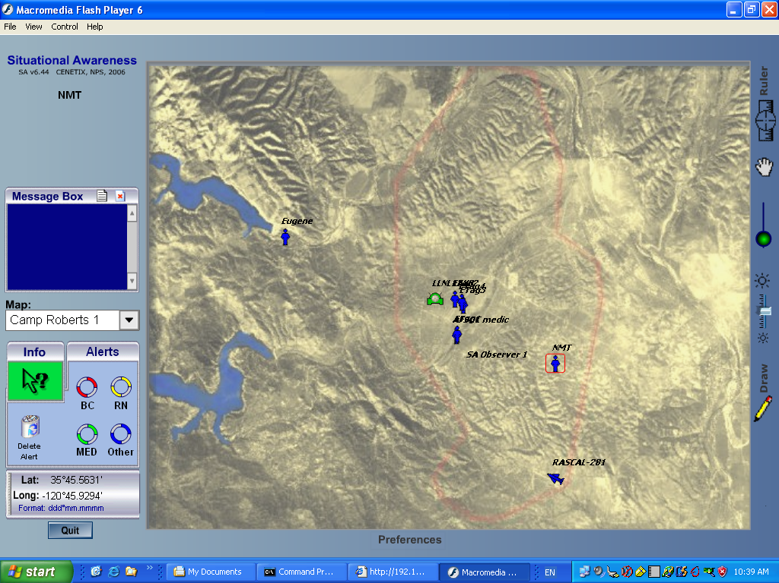
E-tag 1-4 and Rascal UAV seen in TOC SA

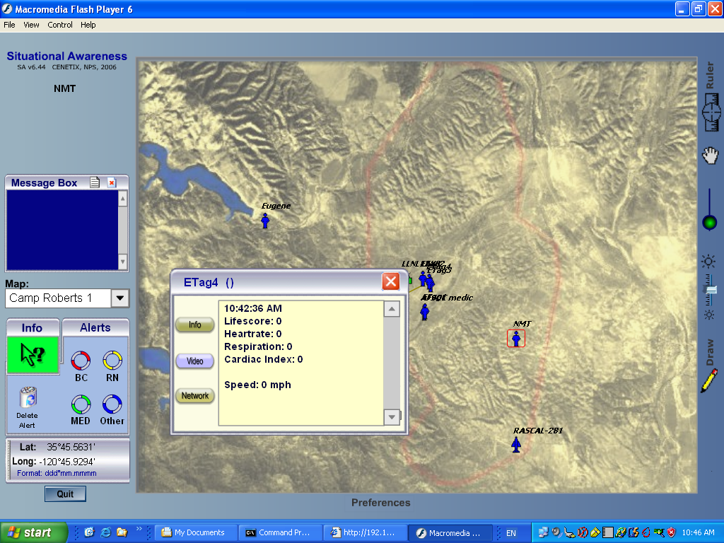

TOC SA with E-tag 4 data

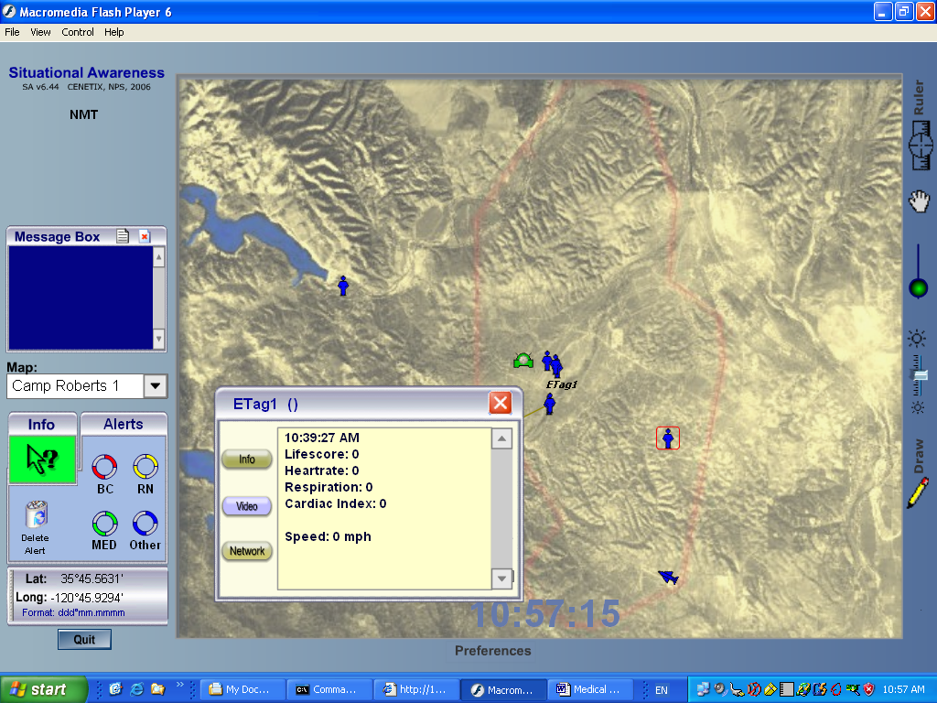

TOC SA with E-Tag 1 data

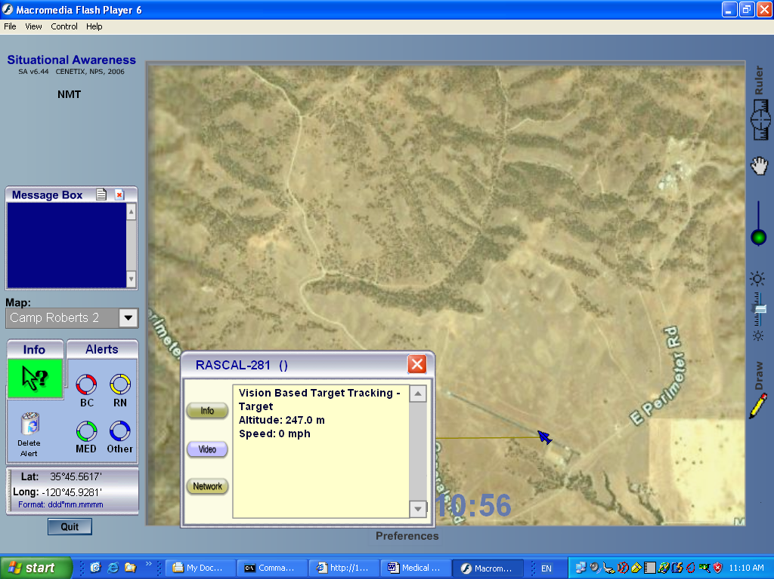

Rascal awaiting takeoff for Medical e-tag flight

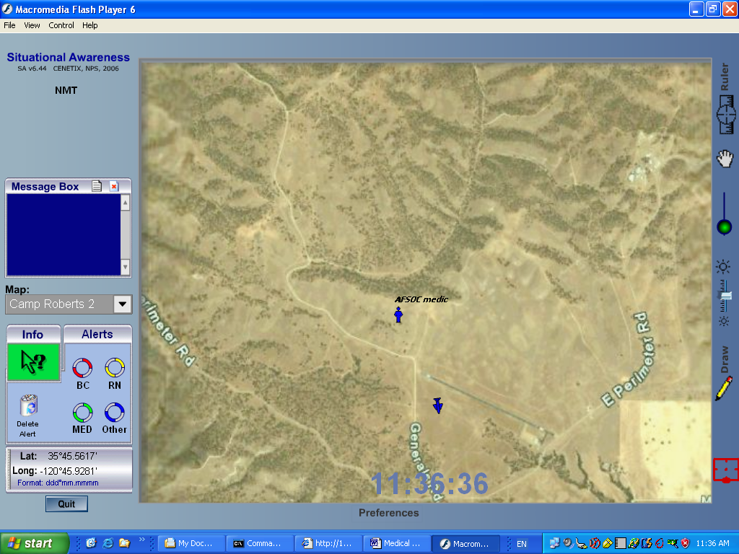

NPS UAV in flight in vicinity of AFSOC medic

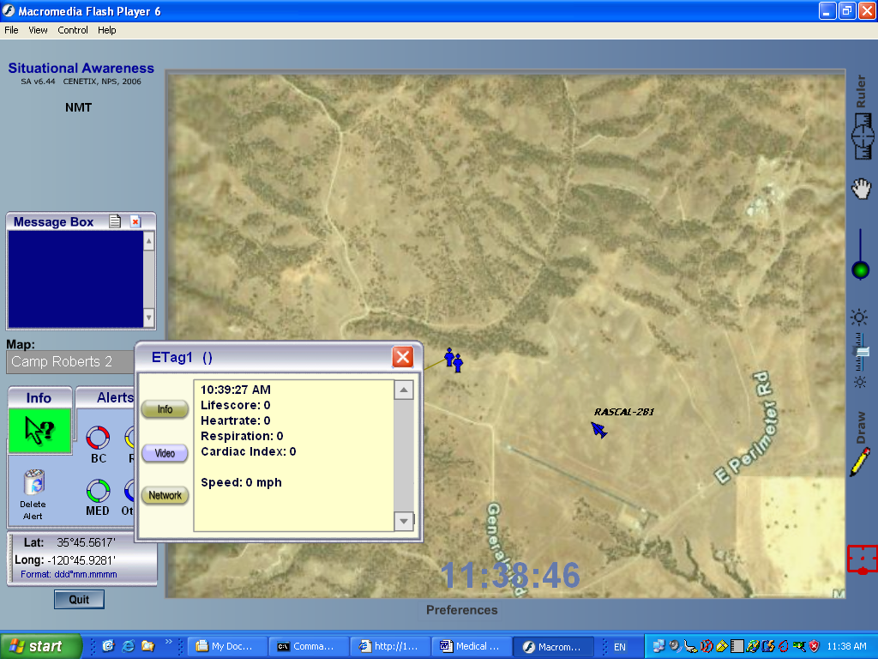

NPS UAV in flight in vicinity of AFSOC medic and e-tag 1

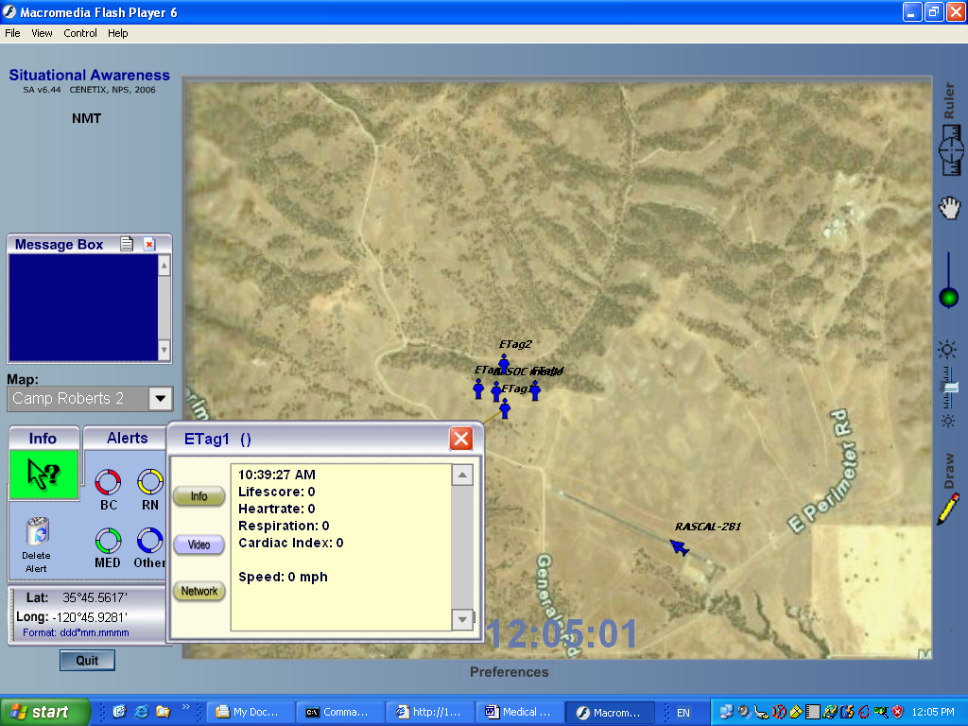

ETAGS 1-4 and NPS SUAV shown in correct positions in TOC SA

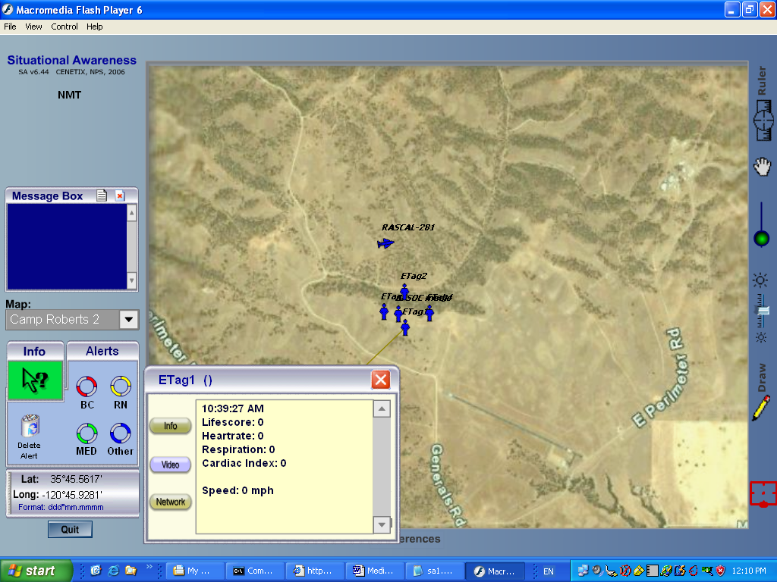

TOC SA wih UAV flying at TOC waypoint
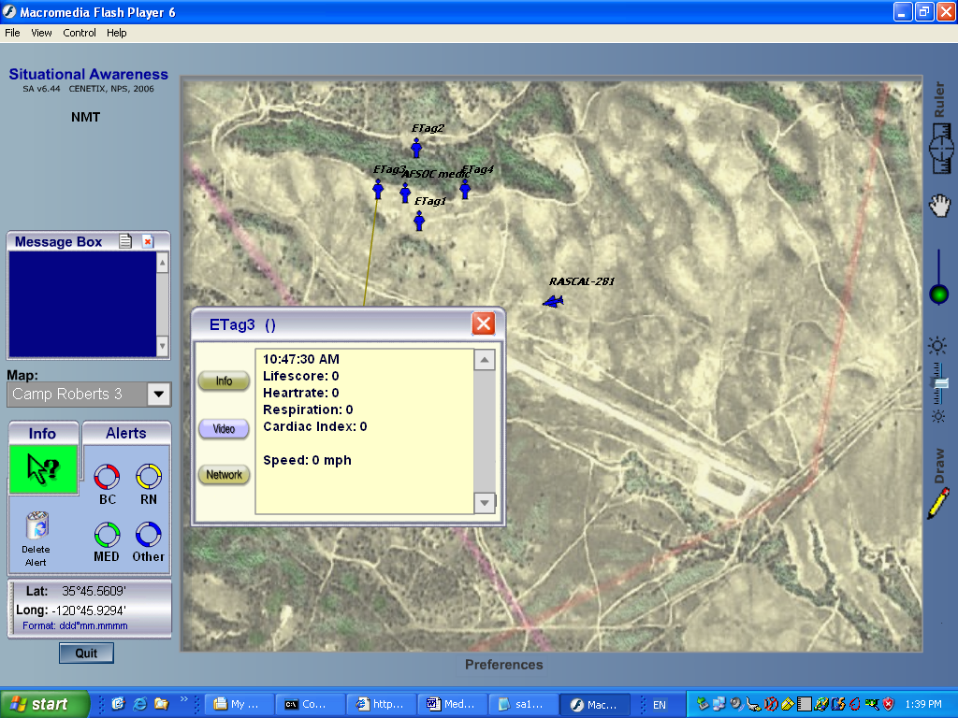

Beginning UAV flight for medical drop #3 under NPS NOC control (SA view is Camp Roberts 3)

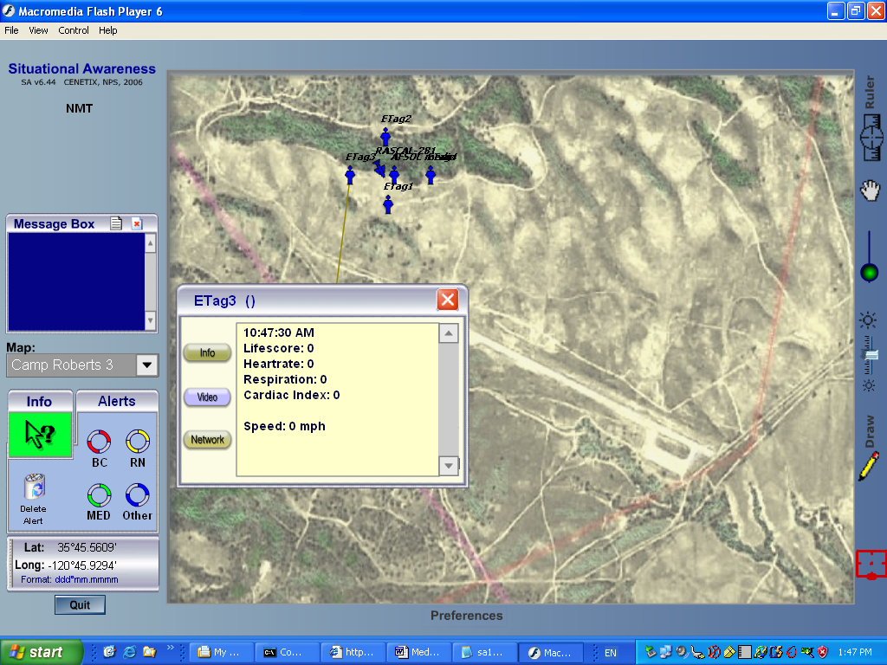

UAV flight during medical drop #3 under NPS NOC control (SA view is Camp Roberts #3)
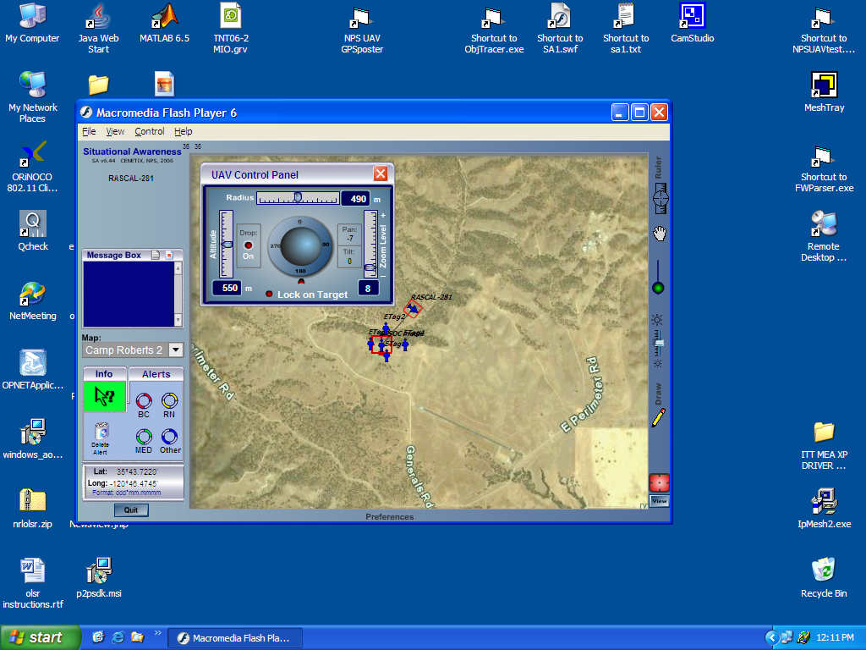

NPS SUAV flying in circular path under TOC control around single point, using waypoint assigned by TOC. For Medical experiment drop

